Calculus BC: Study Guide for Chapter 11

- Express the parametric curve in the form y = f(x): x = tan t y = sec t
(Suggestion: use the Pythagorean identity 1 + tan²t = sec²t)

- Find the slope of c(t) = (e^{t} – 1, sin t) at t = 20

- Find the speed at t = π/4 of a particle whose position at time t seconds is
c(t) = (sin 4t, cos 3t).

- Express the length of the curve c(t) = (sin 2t, 2 cos t) for 0 ≤ t ≤ π as a definite integral and evaluate it on the calculator.

- Calculate the area of the circle r = 3 sin ϴ bounded by the rays ϴ = π/3 and ϴ = 2π/3.

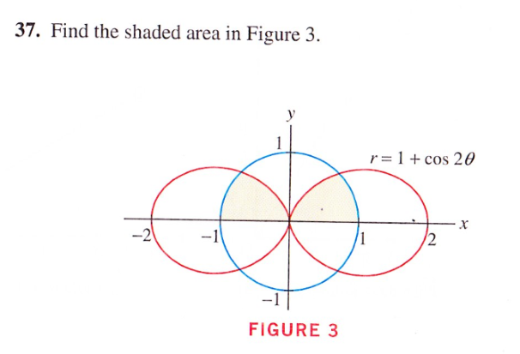
In case it isn’t obvious, the shaded area is the area inside both the circle and r = 1 + cos 2ϴ, and above the x-axis.

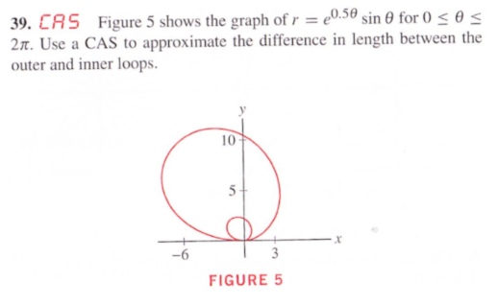

8. Find the slope of r = ϴ at ϴ = π/2.

