Calculus AB
Study Guide for the year’s last quest

Net Change as the Integral of a Rate (5.5)

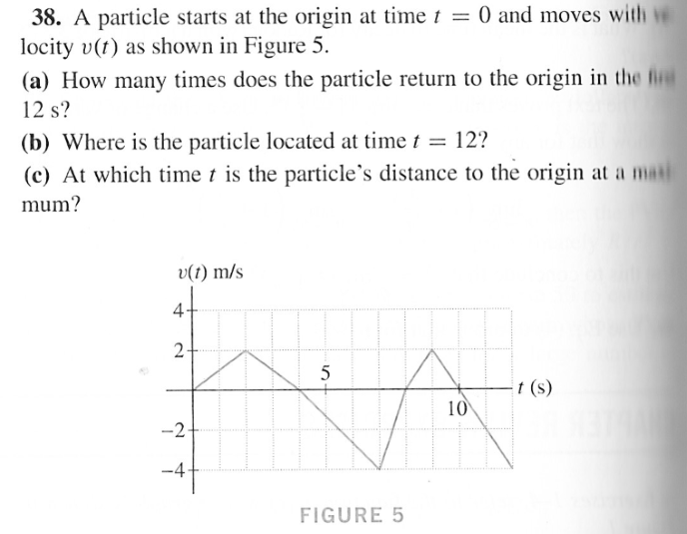
Hard to read words:
Original problem: “velocity”. Part a: “first”. Part c: “maximum”

Substitution Method (5.6)

Evaluate the integral: $\int_{-4}^{-2}{\frac{12x dx}{{(x^{2}+2)}^{3}}}$

Exponential growth and decay (5.8)

The C-14 to C-12 ratio of a sample is proportional to the disintegration rate (number of beta particles emitted per minute) that is measured directly with a Geiger counter. The disintegration rate of carbon in a living organism is 15.3 beta particles/min per gram. Find the age of a sample that emits 9.5 beta particles/min per gram. The decay constant for C-14 is k = -0.000121.

Area (6.1)

Find the combined area of the 2 regions bounded by x1 = y³ - 2y² + y, and x2 = y² – y.

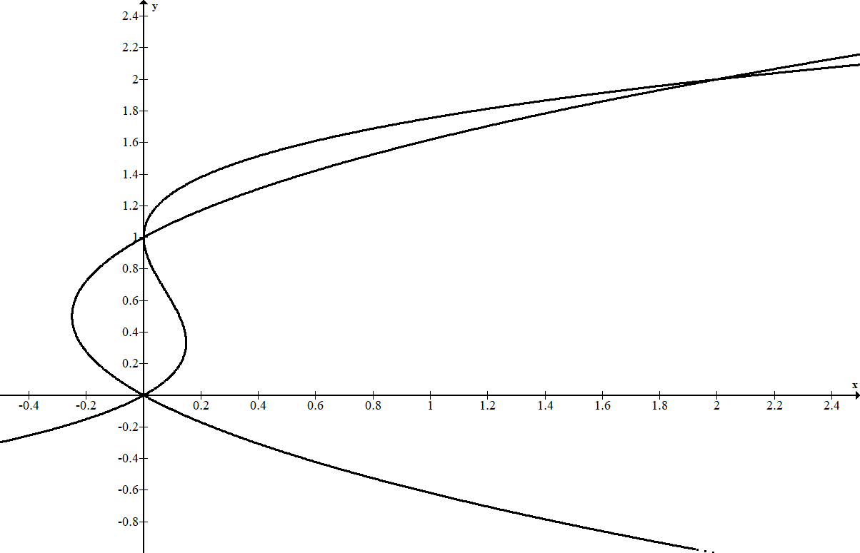

Arc Length (8.1)

Calculate the arc length of y = e^{x/2} + e^{–x/2}, over the interval [0, 2].

Separation of variables (9.1)

Solve the initial value problem: $xyy^{'}=1, with y\left(3\right)=2$

